# CS 499 Module One Assignment Template

Complete this template by replacing the bracketed text with the relevant information.

1. **Self-Introduction:** Address all of the following questions to introduce yourself.
   1. How long have you been in the Computer Science program?

I have been studying this course for the last two years at SNHU.

* 1. What have you learned while in the program? List three of the most important concepts or skills you have learned.

Over the past two years, I have studied various subjects. My core interests were learning object-oriented programming, NoSQL Database (MongoDB), Data structures and algorithms.

* 1. Discuss the specific skills you aim to demonstrate through your enhancements to reach each course outcome.

Computer programming is my passion. I want to learn object-oriented programming using different languages such as C++, Java, and Python. Throughout this degree, I learned how to design and develop databases. I would like to demonstrate my No-SQL-based MongoDB development skills. Besides, I prefer Android programming using Java to establish and improve my skill set.

* 1. How do the specific you will demonstrate align with your career plans related to your degree?

I aim to be a software developer. Computer programming is my major skill. I can program in different programming languages and can develop desktop and mobile applications. Object-oriented programming, NoSQL database, and Android programming skill set align with my career path because Object-oriented programming languages and NoSQL Databases are prevalent and highly demanded skills in the software industry.

* 1. How does this contribute to the specialization you are targeting for your career?

Computer programming skills will greatly contribute to my specialization because I want to be a software developer. Software analysis and design, computer programming, and database design and development will be vital to my career and specialization. My skill set revolves around programming and it will enhance my programming skills.

1. **ePortfolio Set Up:**
   1. Submit a **screen capture** of your ePortfolio GitHub Pages home page that clearly shows your URL.
      1. You already have a repository in GitHub where you uploaded projects in previous courses. Your ePortfolio will reside in GitHub but can link to work at other sites, such as Bitbucket.
   2. Use the GitHub Pages link in the Resource section for directions on:
      1. How to create your GitHub website and publish code to GitHub Pages
      2. Issues, such as adding links to other sites
   3. Paste a screenshot of your GitHub Pages home page with your URL clearly showing in the space below.

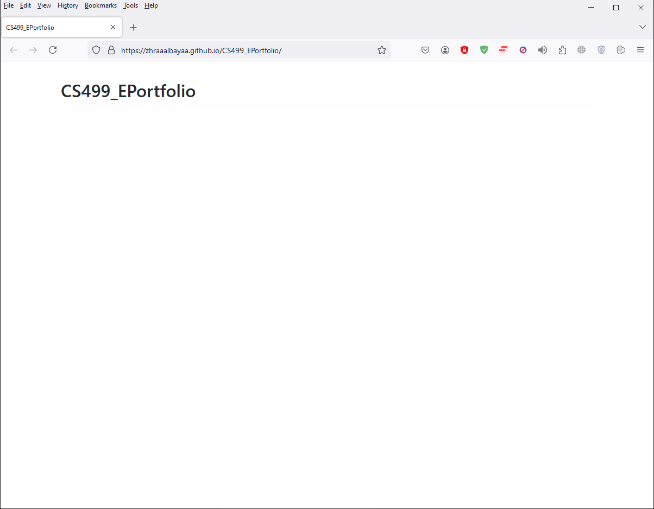

1. **Enhancement Plan:** 
   1. **Category One:** Software Engineering and Design
      1. **Select an** **artifact** that is **aligned with** **the** software engineering and design **category** and explain its origin. Submit a file containing the code for the artifact you choose with your enhancement plan.

The artifact I chose for this category is from the course CS320 I have taken during this  
 degree. It is about Contact Service Testing using Java and Junit Testing framework.

* + 1. **Describe** a practical, well-illustrated **plan** for enhancement in alignment with the category, including a pseudocode or flowchart that illustrates the planned enhancement.

This artifact involves developing a contact management system and testing it using Java and Junit Testing framework. I would like to improve this artifact by adding housekeeping and boundary testing that will improve the quality assurance of this project. I would like to add a setup function() that will perform the housekeeping of the start-up data as this function will be called before every test and make test data available for the subsequent test. I all add boundary testing to rigorously test the Contact class and its repository.

* + 1. Explain how the planned enhancement will **demonstrate** specific **skills** and align with course outcomes.   
         
       Unit testing an application offers quality assurance of the application before it is deployed and used by the end user. The enhanced unit testing will ensure to test of the boundary conditions for the contact and its repository class. The setup() method will ensure to provision of fresh testing data before executing a unit test. These enhancements align with the course outlines as they meet the requirements.
       1. Identify and describe the specific skills you will demonstrate that align with the course outcome.

In this category, I’ll demonstrate object-oriented programming and unit testing to ensure the quality of the code and best coding practices. Software testing is a vital part of application development to ensure the quality of the solution.

* + - 1. Select one or more of the course outcomes below that your enhancement will align with.  
           
         Design, develop, and deliver professional-quality oral, written, and visual communications that are coherent, technically sound, and appropriately adapted to specific audiences and contexts
  1. **Category Two:** Algorithms and Data Structures

1. **Select an artifact** that is **aligned with the** algorithms and data structures **category** and explain its origin. Submit a file containing the code for the artifact you choose with your enhancement plan. You may choose work from the courses listed under Category One.

For this artifact, I would choose a project I did for the course CS300 Vector Sorting using C++.

1. **Describe** a practical, well-illustrated **plan** for enhancement in alignment with the category, including a pseudocode or flowchart that illustrates the planned enhancement.

This artifact involves C++ programming to sort a vector using the QuickSort algorithm. I would like to improve the QuickSort algorithm by introducing a hybrid sorting technique. Empirical studies provided that When the quick sort is mixed with selection sort for a smaller dataset threshold, for example, size 10, this hybrid algorithm performs better than standalone quicksort.

I will import this artifact by introducing hybrid quicksort by mixing sorting of smaller partitions by selection sort. For example, if the partition size is 10, this partition will be sorted by selection sort otherwise it will be sorted by quicksort. The quicksort algorithm combined with selection sort will improve the performance of this artifact.

1. Explain how the planned enhancement will **demonstrate** specific **skills** and align with course outcomes.
2. Identify and describe the specific skills you will demonstrate to align with the course outcome.  
     
   This artifact will demonstrate data structure and algorithm skill set as I will use the hybrid algorithm to sort a vector. The algorithm is a mixture of Selection sort and quick sort. The selection sort will be used to sort the vector partition whose size is smaller than a threshold.
3. Select one or more of the course outcomes listed under Category One that your enhancement will align with.  
     
   Design and evaluate computing solutions that solve a given problem using algorithmic principles and computer science practices and standards appropriate to its solution while managing the trade-offs involved in design choices.
   1. **Category Three: Databases**
      1. **Select an artifact** that is **aligned with the** databases **category** and explain its origin. Submit a file containing the code for the artifact you choose with your enhancement plan. You may choose work from the courses listed under Category One.   
           
           
         For this category, I would like to choose an artifact from CS340 Client and Server application class. This artifact involves creating MongoDB database.
      2. **Describe** a practical, well-illustrated **plan** for enhancement in alignment with the category, including a pseudocode or flowchart that illustrates the planned enhancement.  
           
           
         I will create a MongoDB Database. I’ll add an Index to the database to improve its search and find functionality.
      3. Explain how the planned enhancement will **demonstrate** specific **skills** and align with course outcomes.
         1. Identify and describe the specific skills you will demonstrate that align with the course outcome.  
              
            This enhancement will improve the database Search Functionality. The database search is a basic requirement in database-driven applications. This skill will demonstrate how we can improve a database application by adding indexes to make searches efficient.
         2. Select one or more of the course outcomes listed under Category One that your enhancement will align with.  
              
            Demonstrate an ability to use well-founded and innovative techniques, skills, and tools in computing practices to implement computer solutions that deliver value and accomplish industry-specific goals.
4. **ePortfolio Overall Skill Set**
   1. Accurately describe the **skill set** to be illustrated by the **ePortfolio** **overall**.
      1. Skills and outcomes planned to be illustrated in the code review

The skillset involved object-oriented programming, software testing, and database design and development.

* + 1. Skills and outcomes planned to be illustrated in the narratives

Software application development involves working with various programming languages, databases, data structures, and algorithms. Improvements in applications are always required due to newer requirements, changing dynamics and end-user expectations, and security vulnerabilities found during application execution. The outcome of these skill sets will be improved existing artifacts and enhanced applications.

* + 1. Skills and outcomes planned to be illustrated in the professional self-assessment

For this portfolio, object-oriented programming skills, software testing skills, and database design and development skills will help increase my programming knowledge and how existing applications or artifacts can be enhanced by utilizing newer knowledge and better development plans.